Note : all the pages are not following the exact design style as given, the designs are made in a way to enhance the user experience, reduce the friction and good aesthetics. Implementing the same in the development is non-negotiable**.**

In many places like this the design is not good. Follow the designs given,

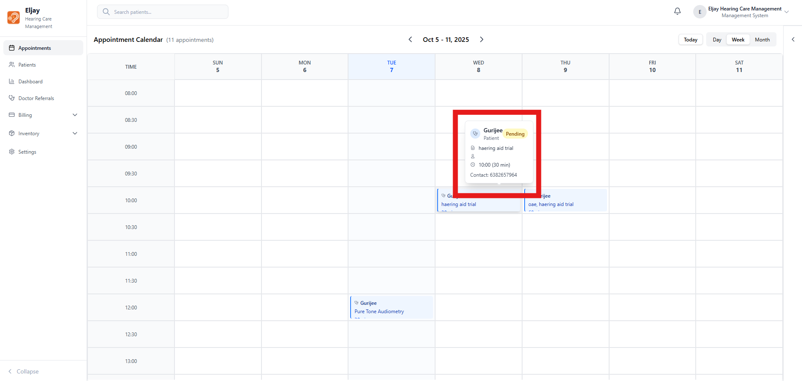

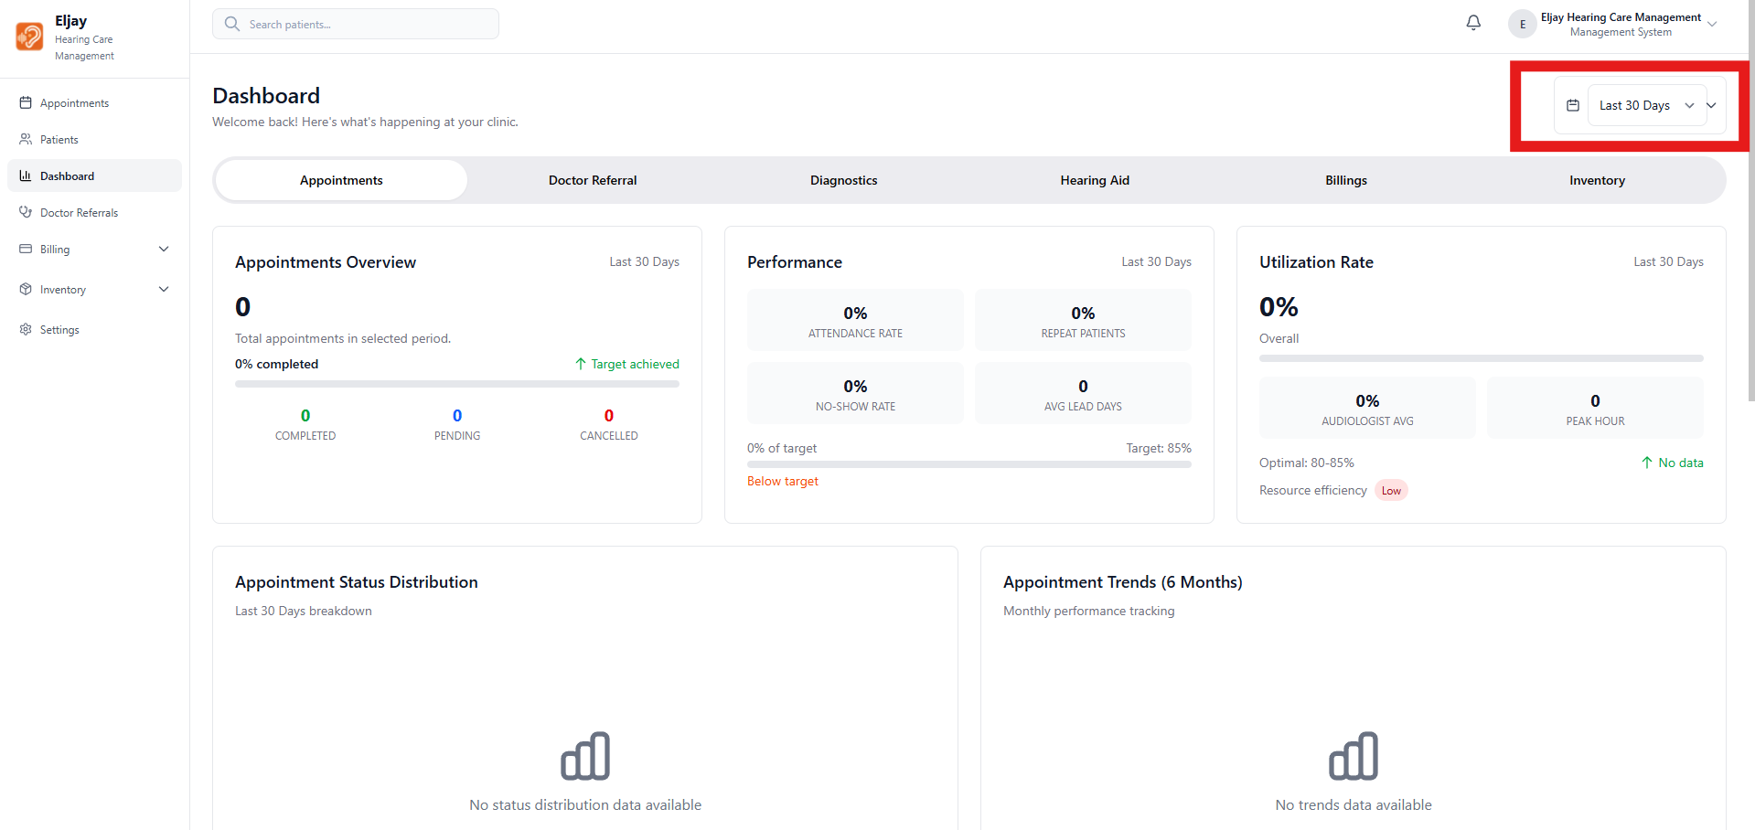

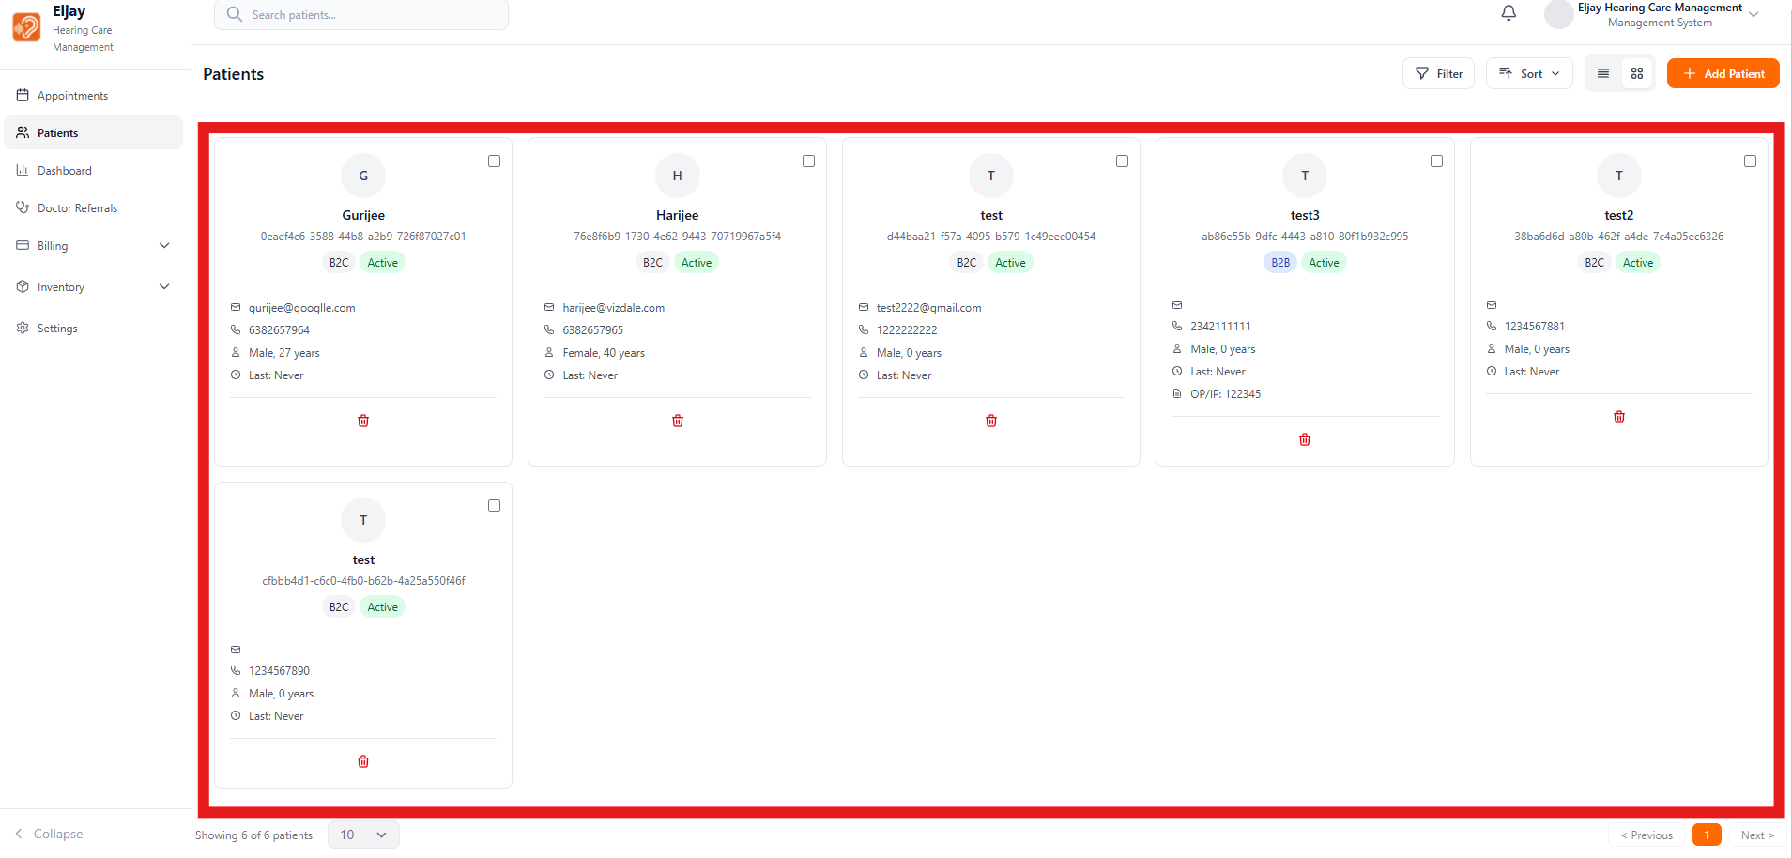

1. The Year dropdown is starting from 1925 as default, which is not an all time scenario, rather it can start from 70s or 80s
2. Also we are able to select year after 2025, block the upper limit to the present day.
3. When Calendar is pressed a scroll bar is appearing remove it

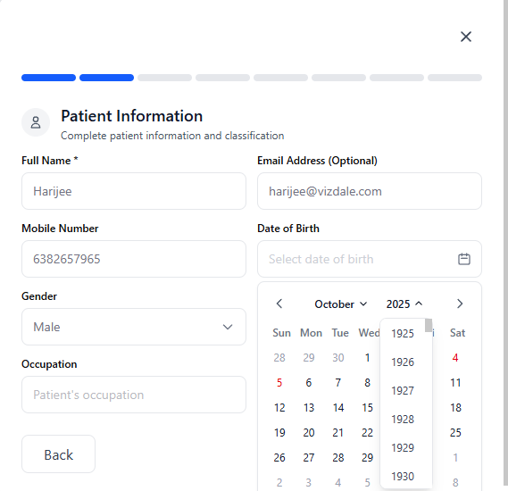

1. In the appointments booking tab, the selection of appointment date and time should not be in the past, and the future days can also be limited to 60 days or something.
2. Remove the scroll bar here also
3. Should there be a simple drop down for the duration? The existing one is not giving the feel of it a box for typing.
4. Can someone book a 90 minute session at 8pm? Isn't there a closing day of the facility?

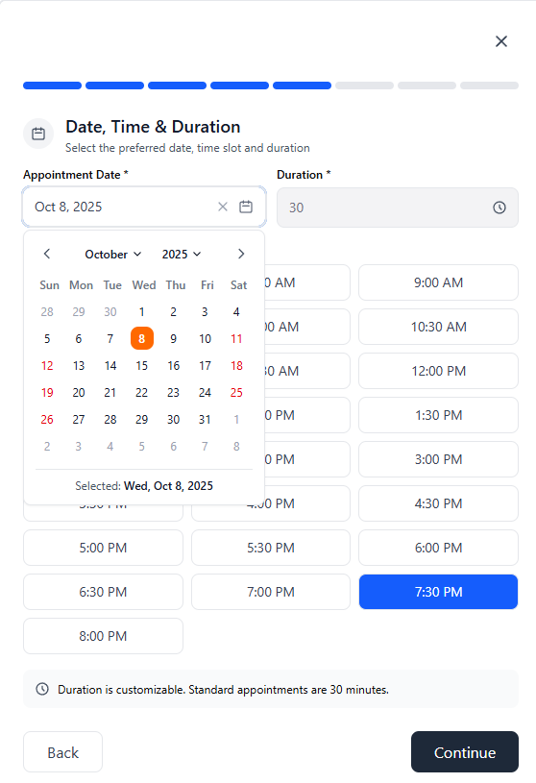

1. An error state appears here like this, need an explanation on what is this, why is this occurring so that it can be corrected, and if this error can be corrected somewhere before then it must show in that particular window itself.
2. Is a scroll bar required here? Is so it must be going along with our design theme

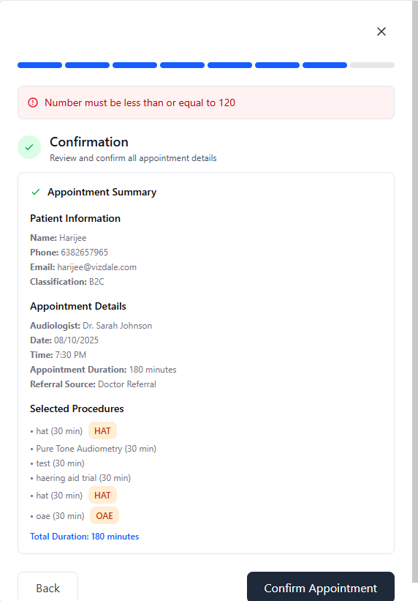

1. After the first error state I again clicked confirm appointment, but this error pops up again, it looks like in the first button click itself the number got registered. This needs to be fixed, the button can be disabled after the first error. BTW, there should be no error in the last section right? All the errors must be fixed earlier itself.
2. Even after fixing the error I am not able to create an appointment, it is still showing this number already exists.

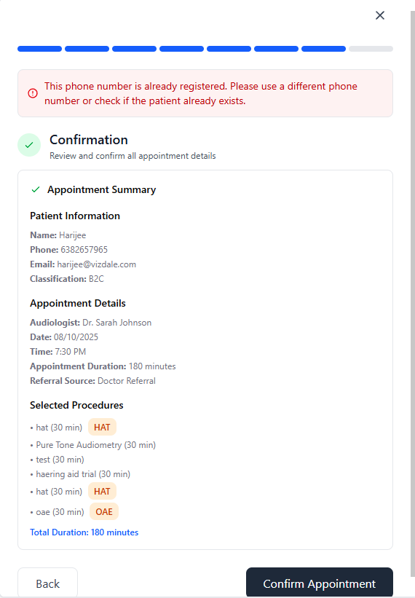

1. Getting this pop up of invalid, I don’t know what is the error I made!
2. If I enter 90 minutes in the appointment and click only HAT in the procedures this invalid error is popping up.
3. Did it occur because of me entering 90 minutes in the duration and clicking HAT in the procedures?
4. Even after fixing this the same error of “invalid” is popping up
5. Tried and tested all permutations and combinations, still shows invalid

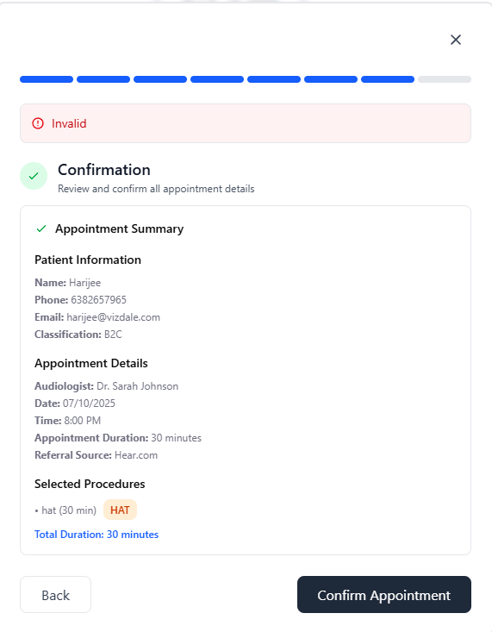

1. In the task creation field also, the selection of years in the past till 1925 is present.
2. A better UI can be placed for the calendars.
3. Past dates can be kept in a gey color.
4. Should we show the festival or govt holidays also in red color?
5. Selection of tasks due date can be restricted to a 2 week or 30 days period   
   (based on ops.)  
   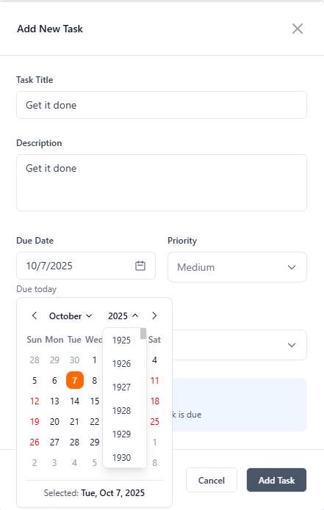
6. task view [today]” not working
7. What is the bar for today? For showing the total number of tasks in that particular day?
8. The word today is not changing even if the view is changed to the next day. Should the content on this bar be changed?
9. The button next to the dropdown icon of the "Audiologist Overview” is not functional, if it is then the user is not notified that an action has occurred.
10. Previous day button not working from the present day.

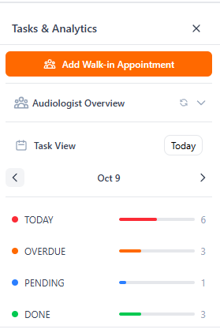

The scroll bar for the tasks is not looking like it is for the tasks alone rather it is looking like for the entire page.

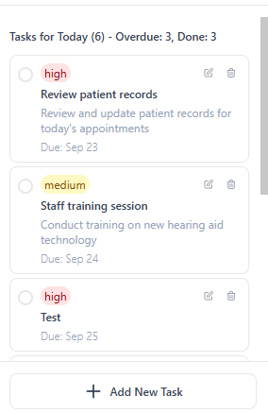

1. Booked two different appointments for two different patients with two different doctors at the same time, but it is showing only on the monthly page but not on day and week page.
2. This view should look like the design

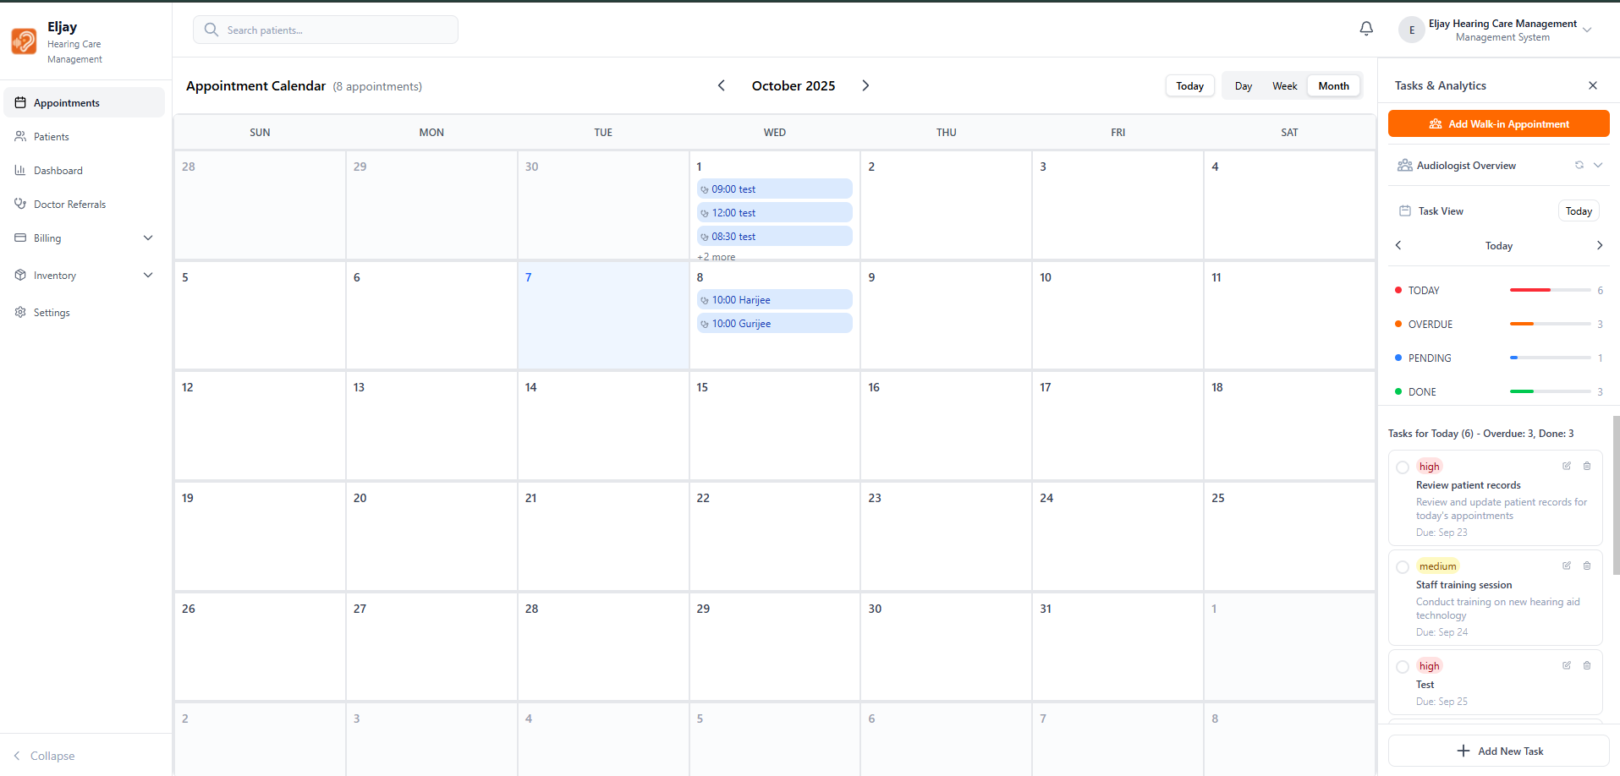

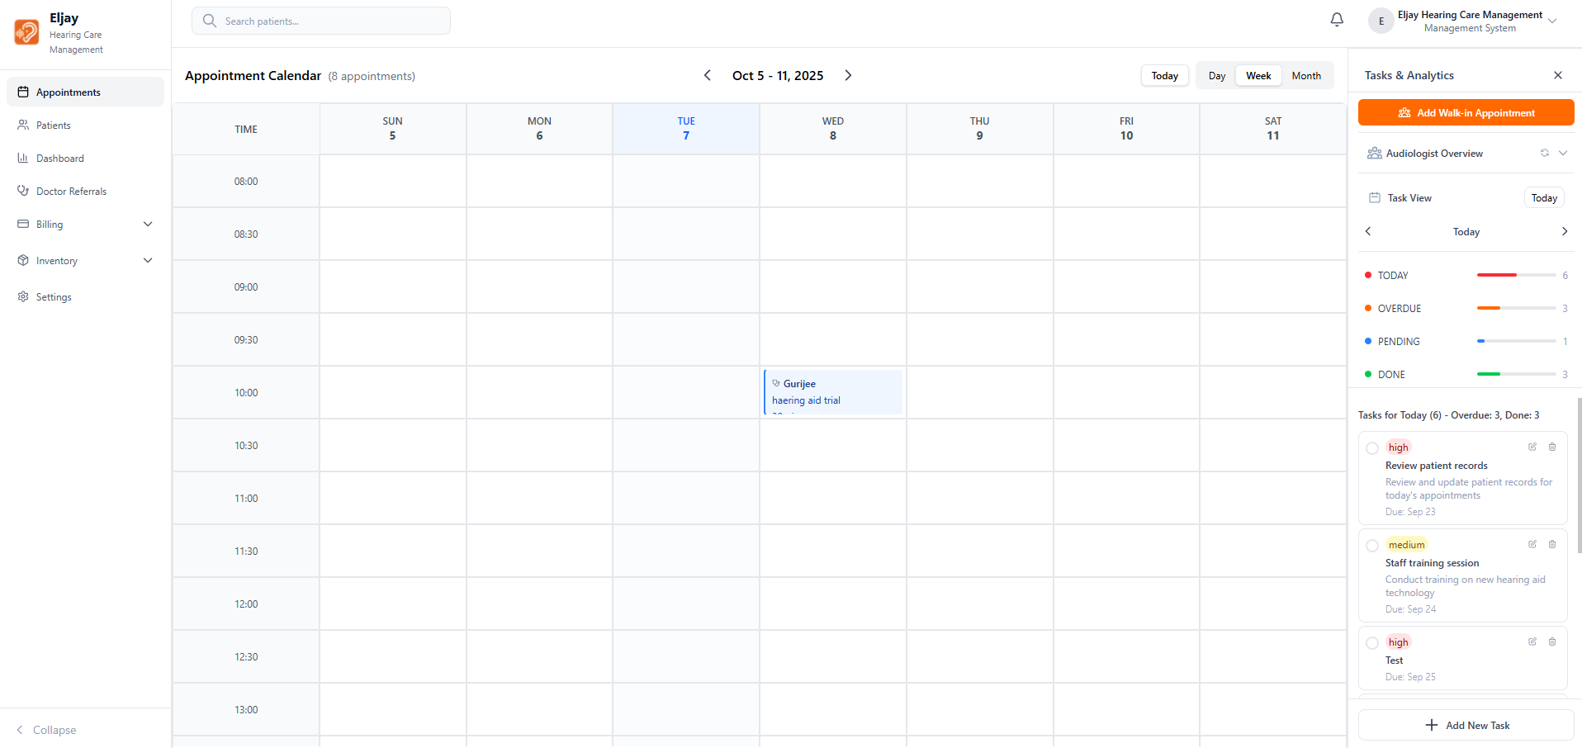

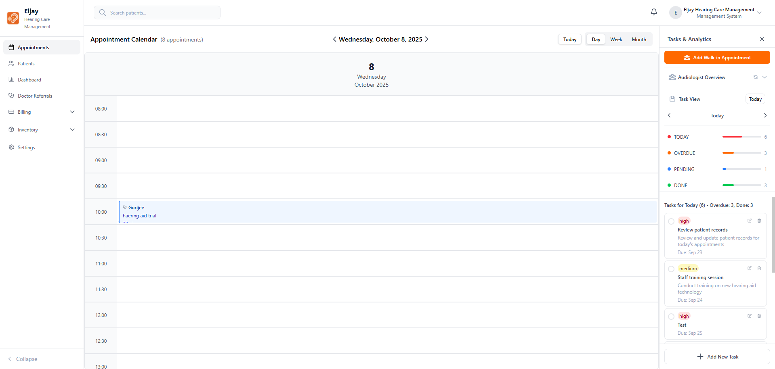

1. Occupation was not a required field in the appointments booking phase, but it is marked required here, but I am able to save the details even without it.
2. The country code must come before the phone number right?
3. It looking like nothing is happening while pressing the Appointment History button, ideally some action must happen, Ideally I would be taken to the section if I press it, but since the Patient’s information are limited no action is happening, and the patients information will be limited and same for all, so this button will look like unfunctional, this must be fixed.
4. The Secondary side bar here is still not made sticky, and the primary side bar also vanishes along with it, which is looking very odd.
5. The options button present in the design is not present here, and there are two edit buttons.
6. The design is not executed properly for the secondary side bar.

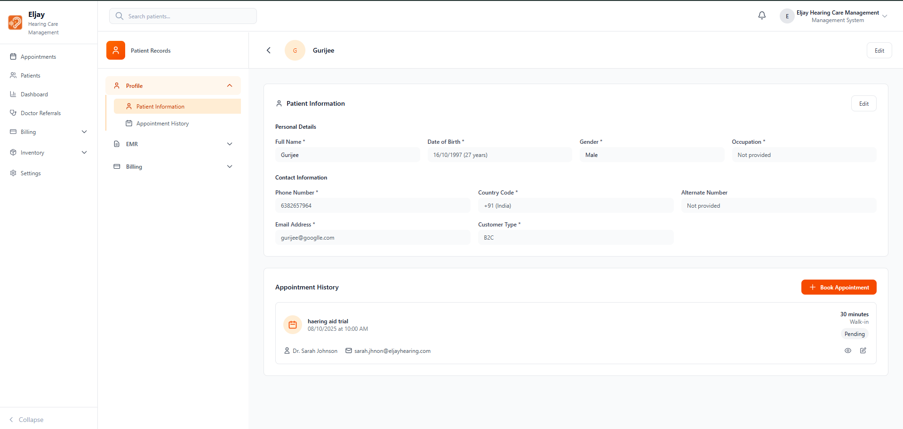

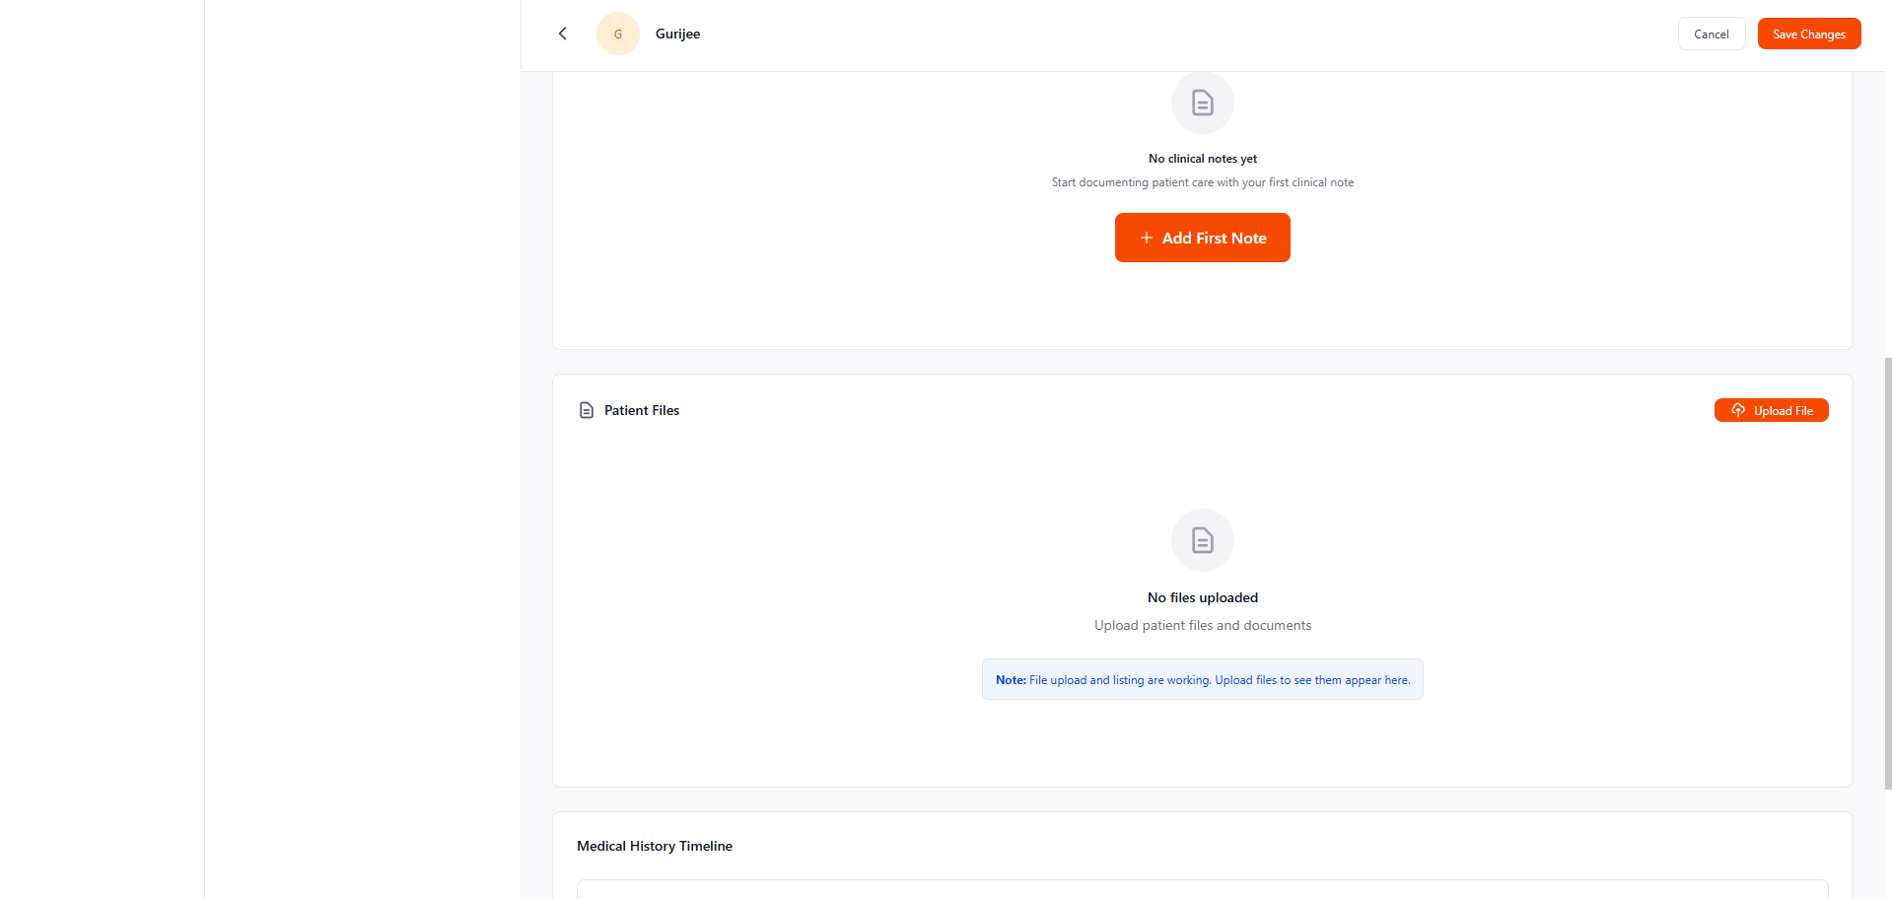

I am not taken to the sections properly when I press the buttons in the secondary side bar, the scroll is happening inappropriately.

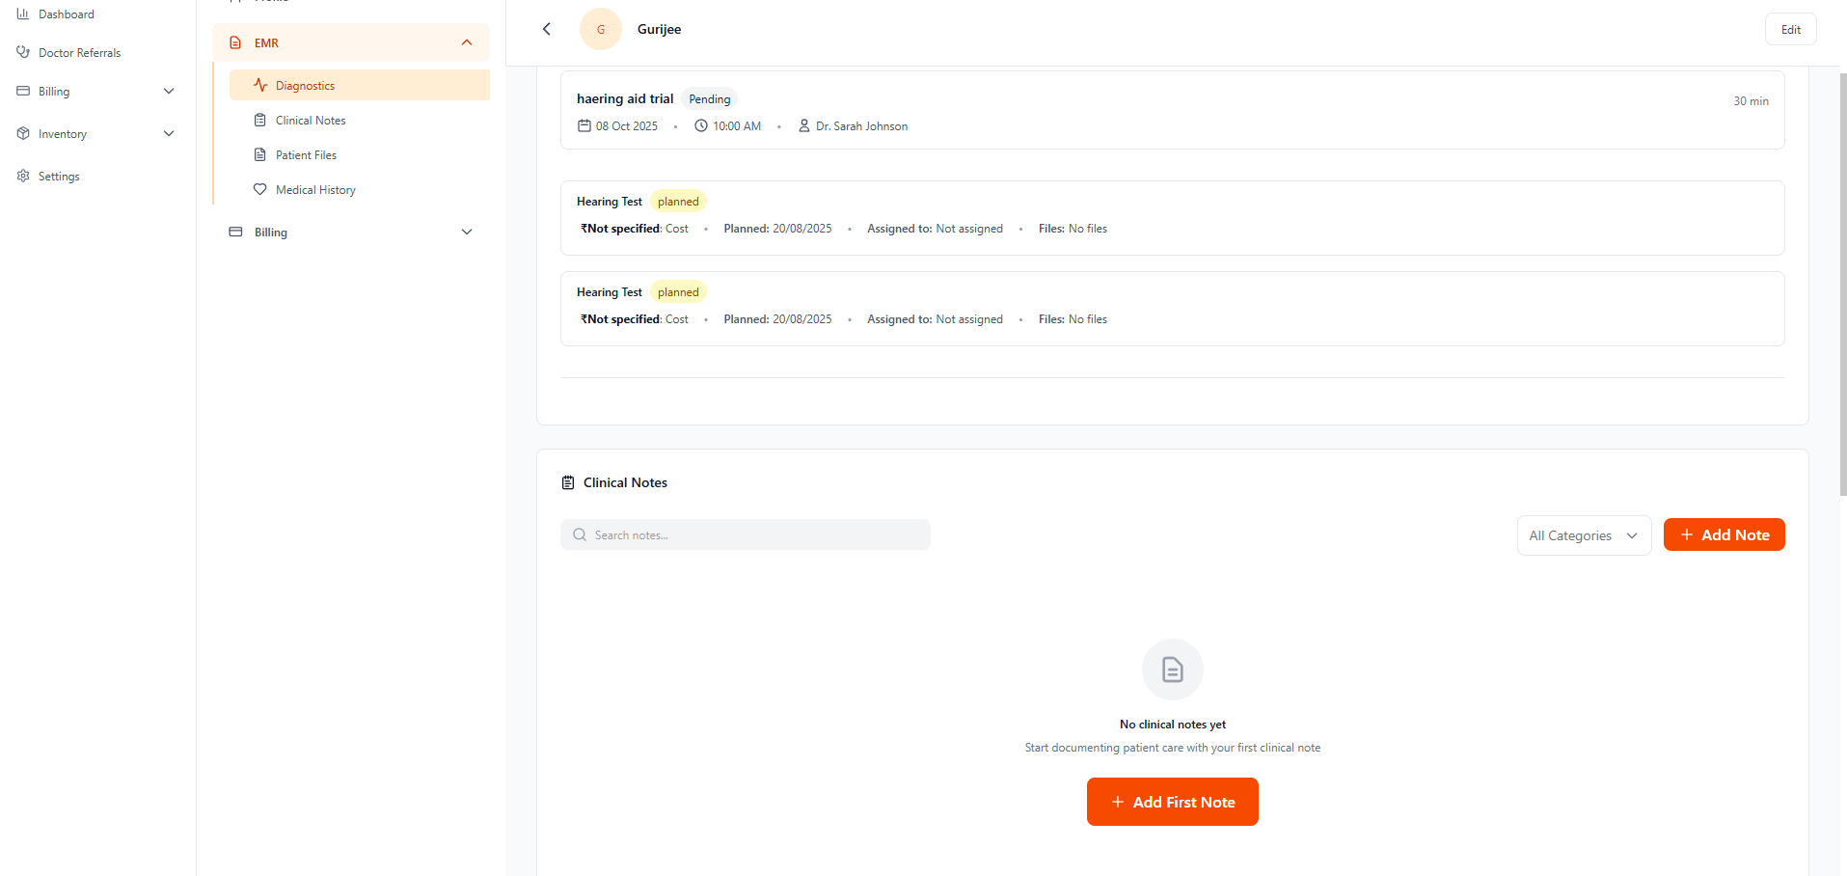

1. I am able to open the filer and sort in the same time, overlapping each other
2. The email sort is not happening, is it needed?

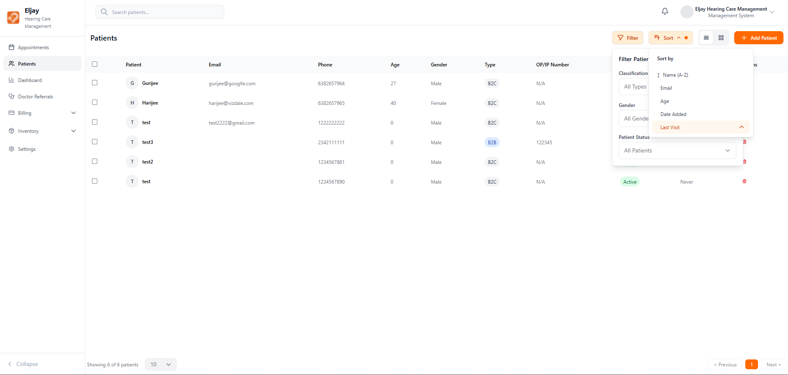

1. Why is the general dropdown naked mandatory? Why is only one present in the dropdown?
2. The delete function of the clinical note is not happening, and the pop up for the delete function should come as a pop up on the screen right?

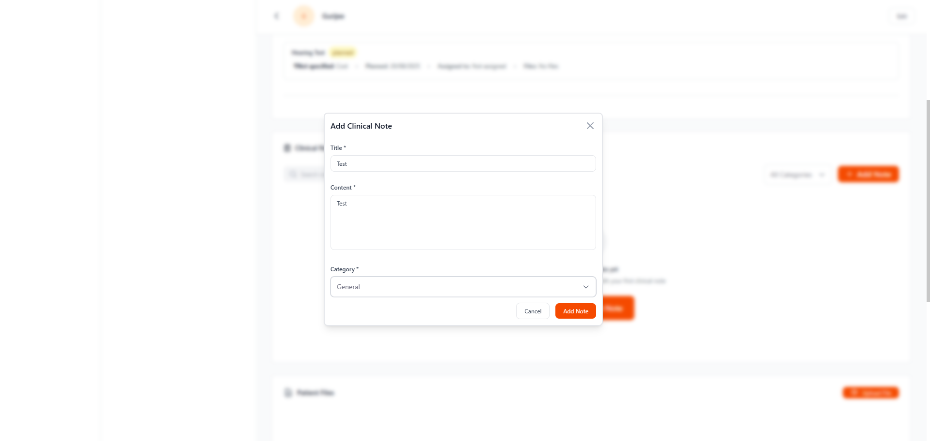

Patients grid view is not looking like the design

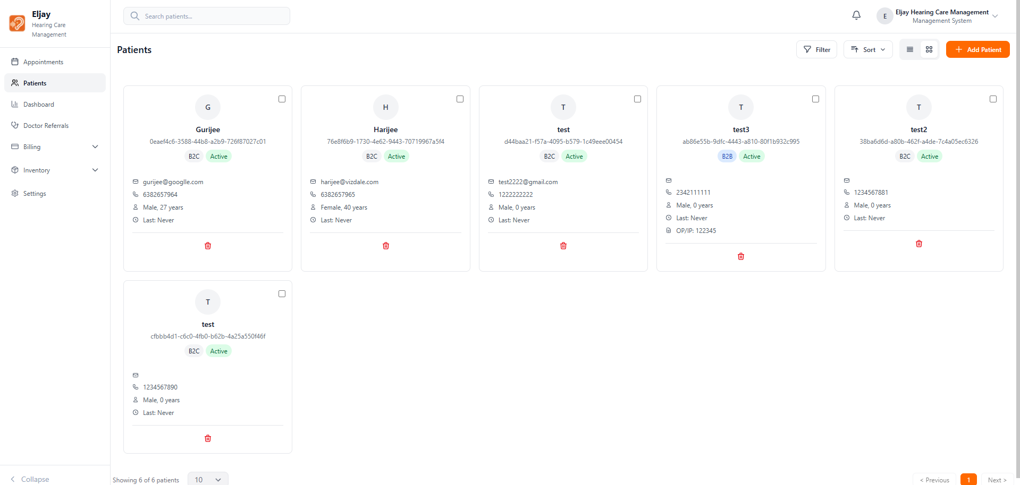

1. Multiple files upload is not possible
2. The maximum file upload size must be conveyed somewhere before uploading, not after uploading it.
3. I am still able to press the upload button even after it tells me the file is larger than 10mb.
4. There should be a discard button after uploading a document, especially if the file is larger.

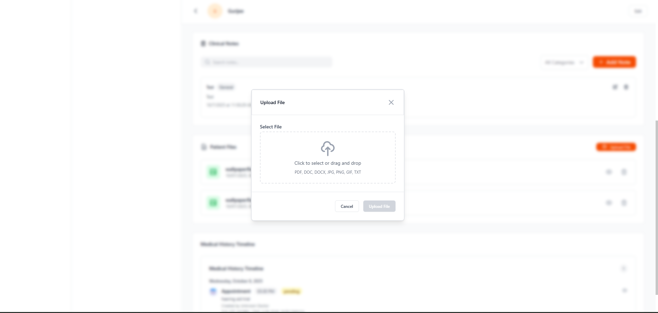

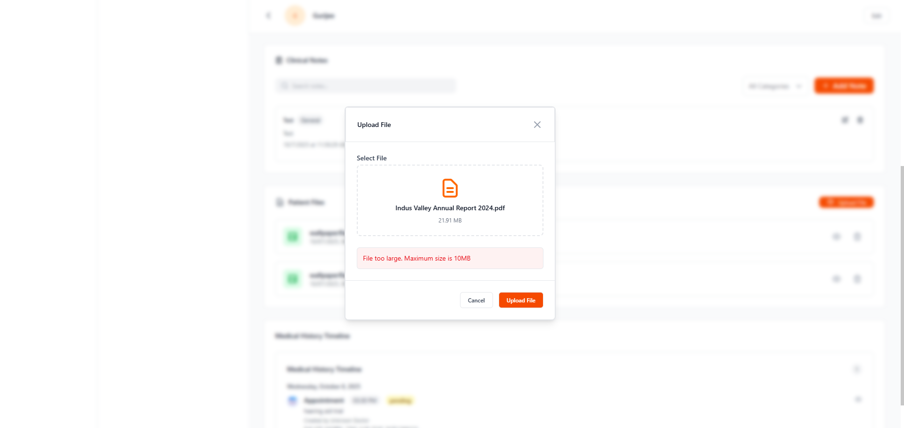

The time mentioned in the documents uploaded are not matching the real uploaded timing.

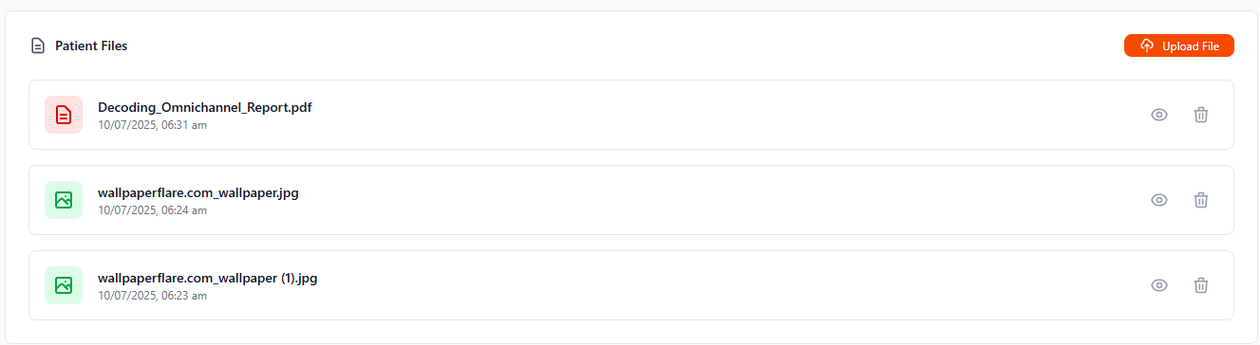

The eye button is not working

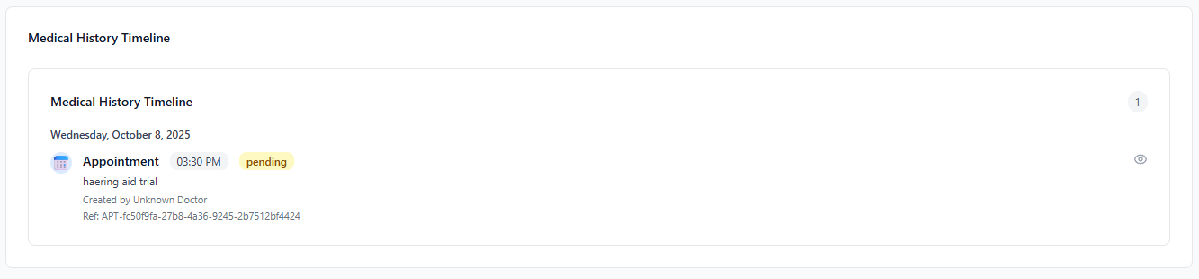

Can Payment be collected even after marking as absent?

Even after completing the profile fully, it is still showing incomplete profile.

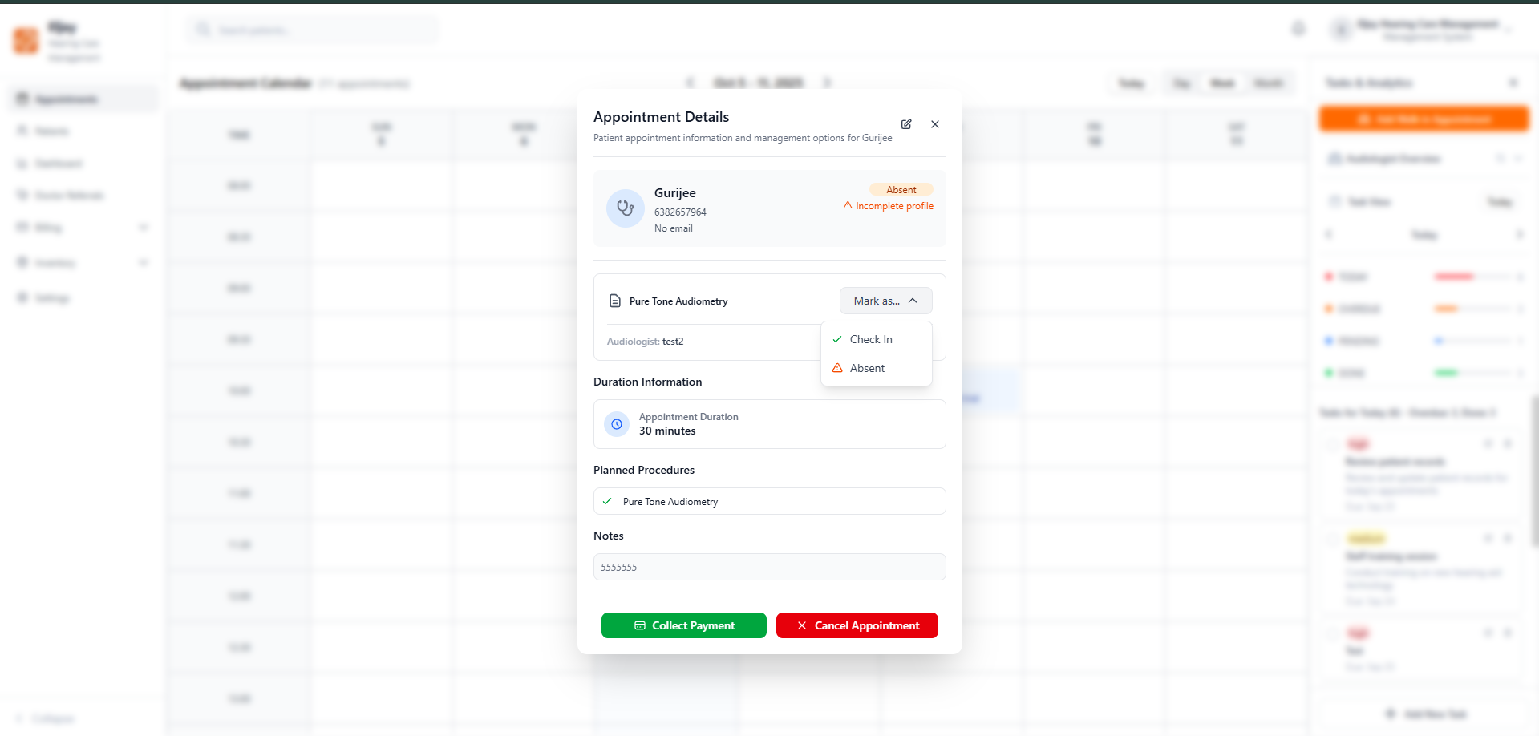

In billing, partial payment the calendar’s year is in an indefinite loop, this must be restricted to a confined timeline.

There should be limits for the amount according to the payment method right?

The amounts entered in partial payment, can they be recorded in the future?

Check if all the calculations are happening properly.

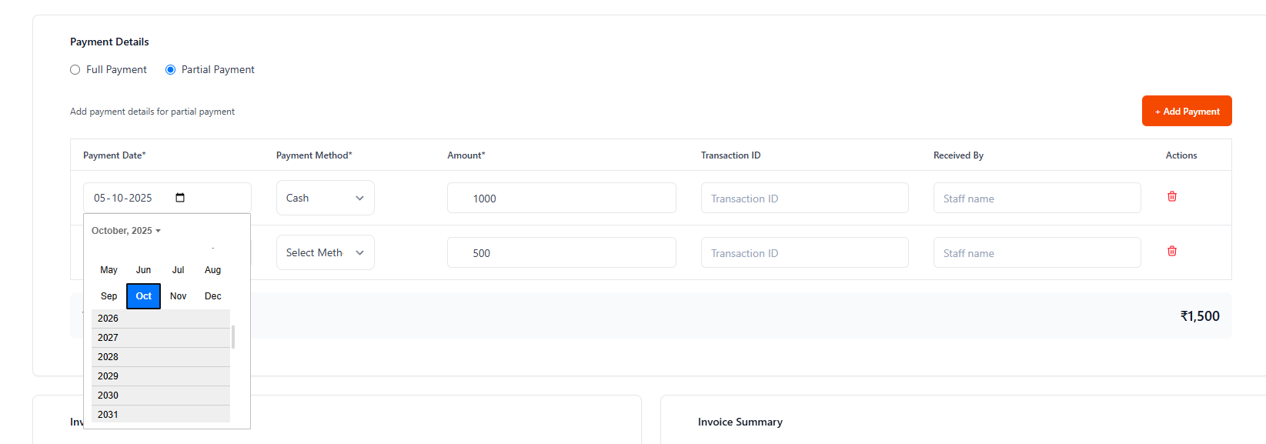



Year selection in record payment must be fixed

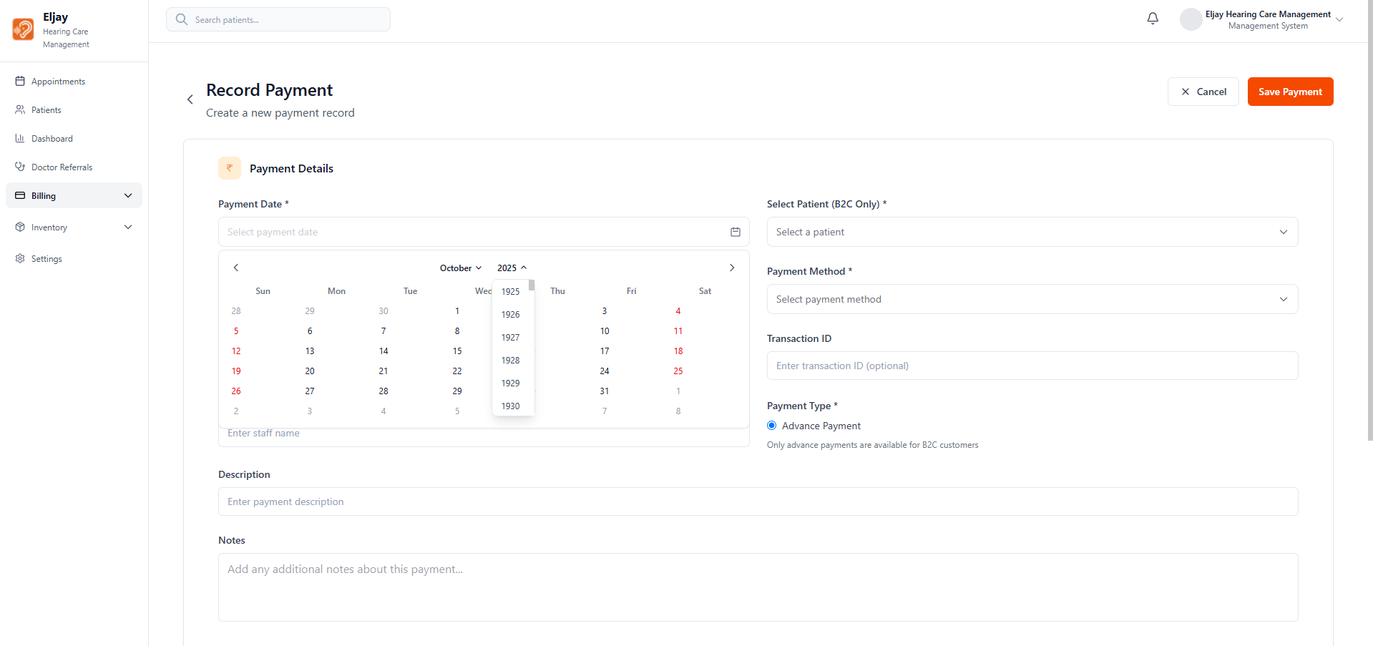

Calendar’s year must be fixed in expenses

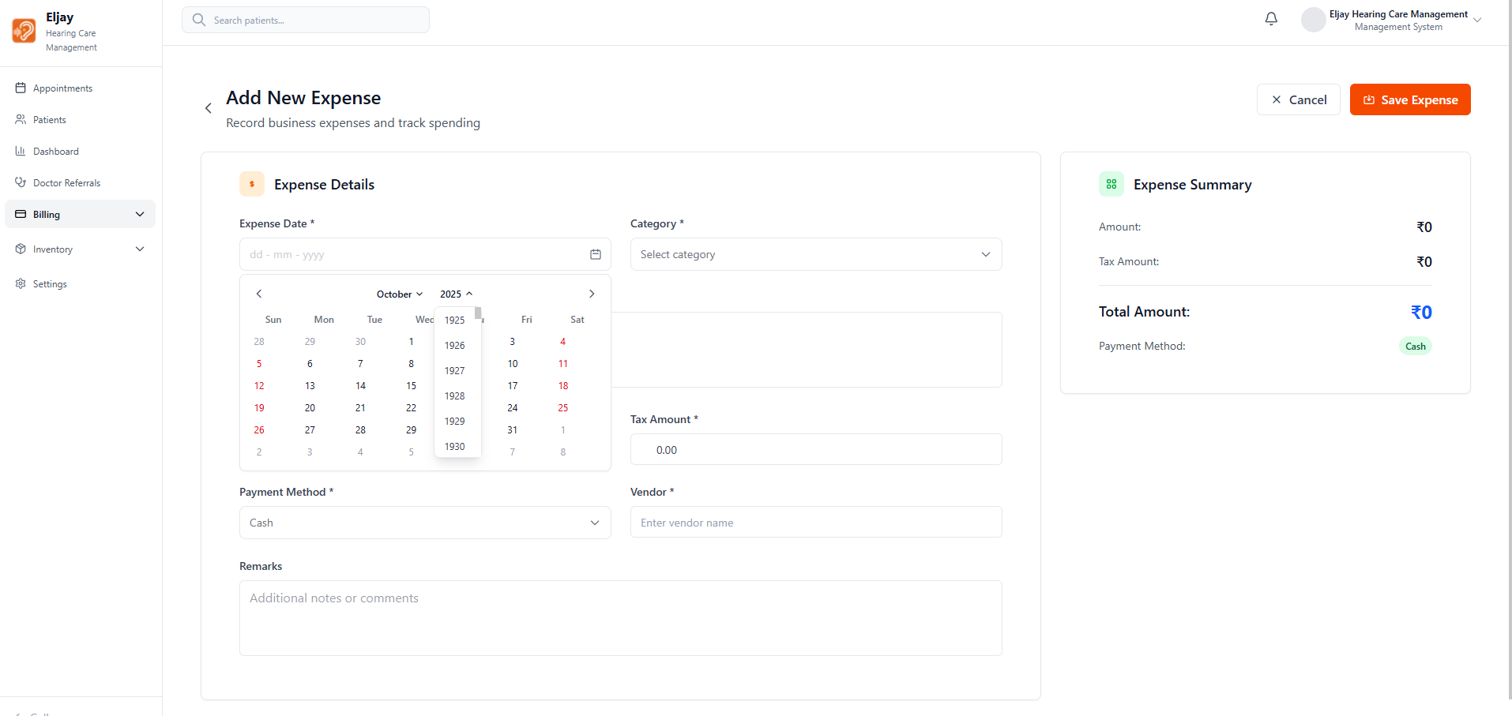

Minimum quantity cannot be lesser than current quantity

Error is not specified while adding an item

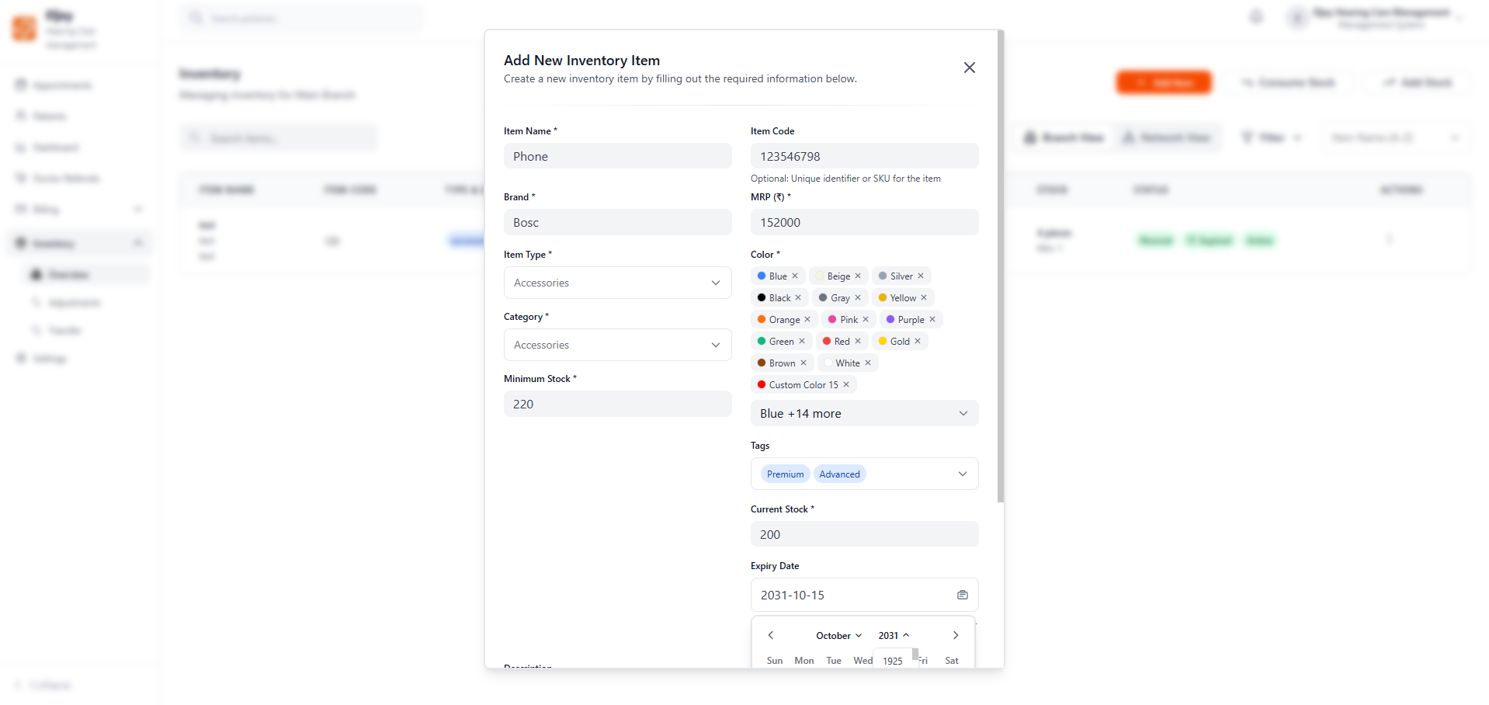

Why is the data field in the add stock kept for customization? It should be captured automatically.

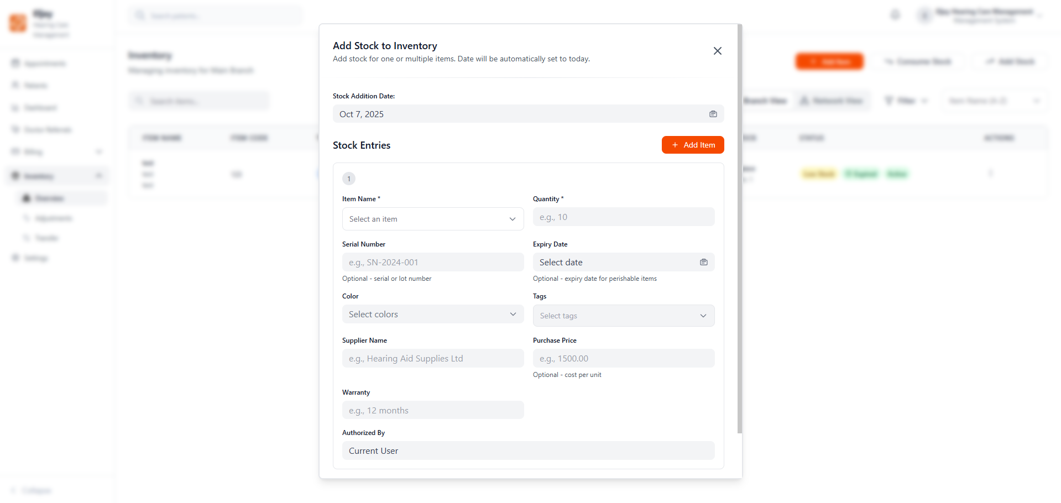

In Inventory and settings many places the hand symbol is not appearing in the places where we can click.

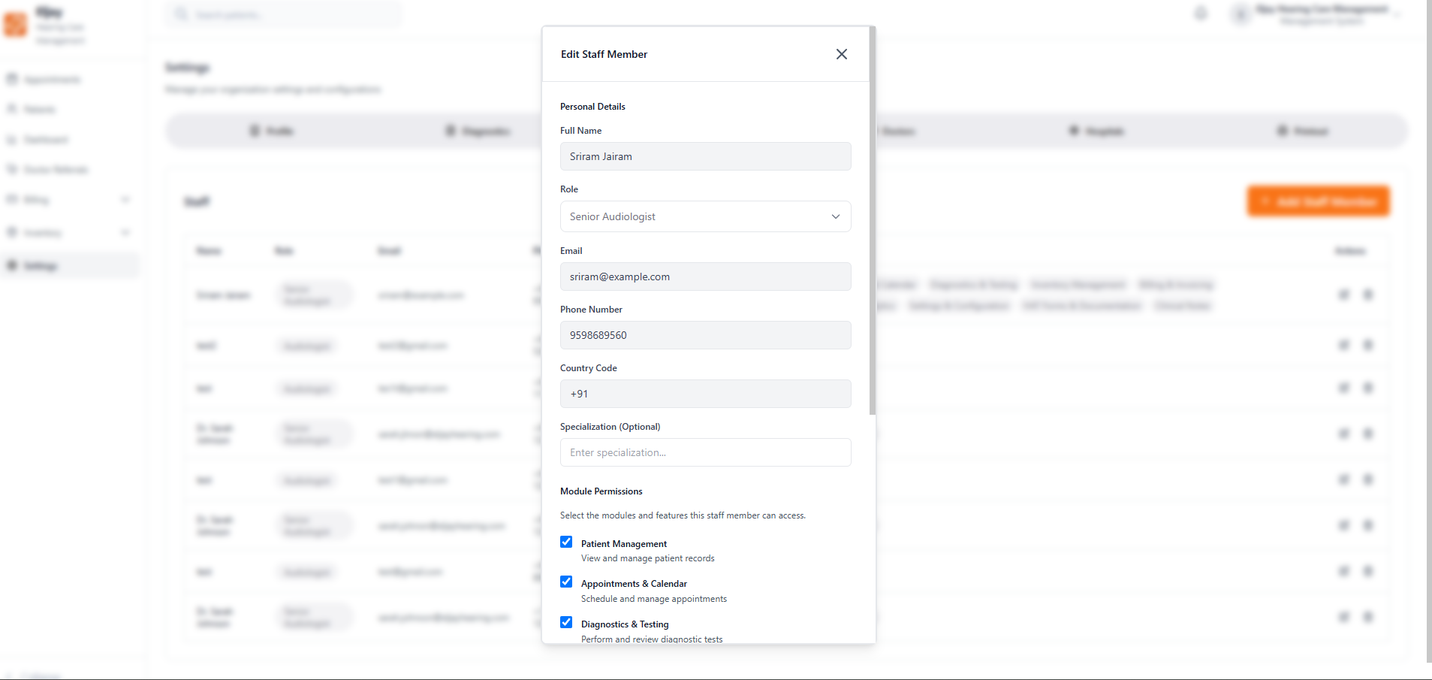

Fields are not market required in a many places in settings

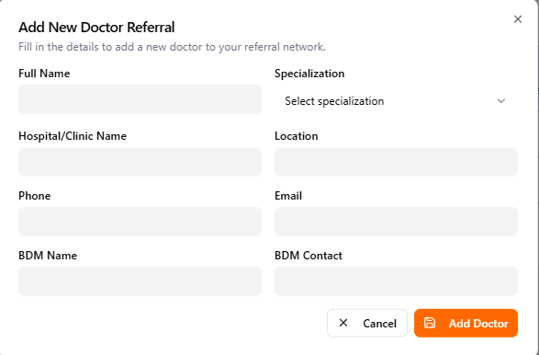

The added New doctor is not reflecting

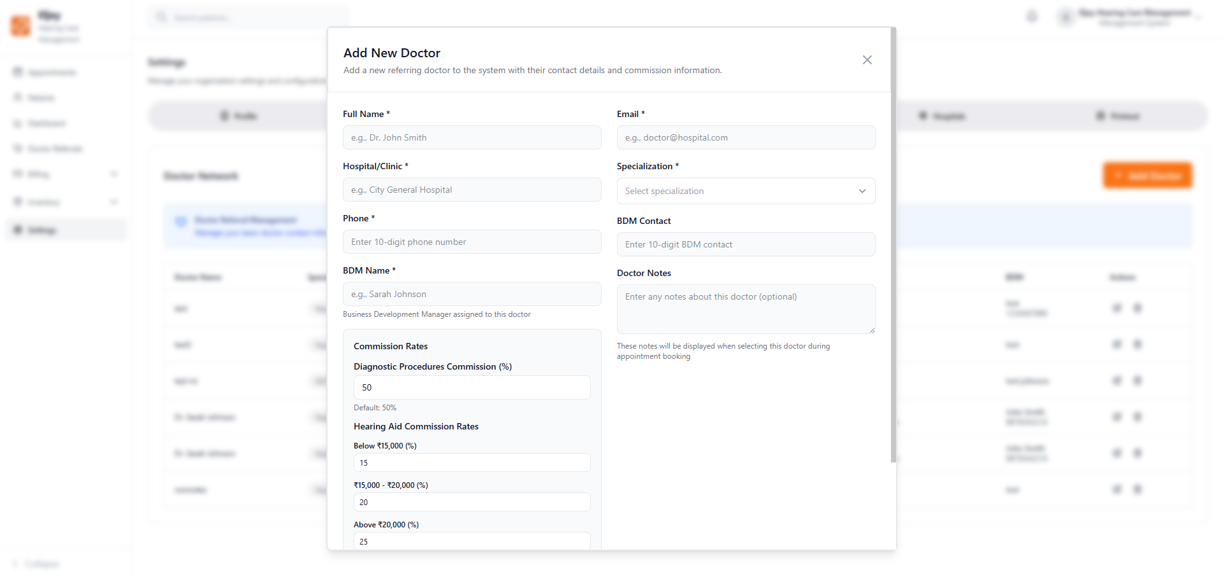

Not able to add hospital

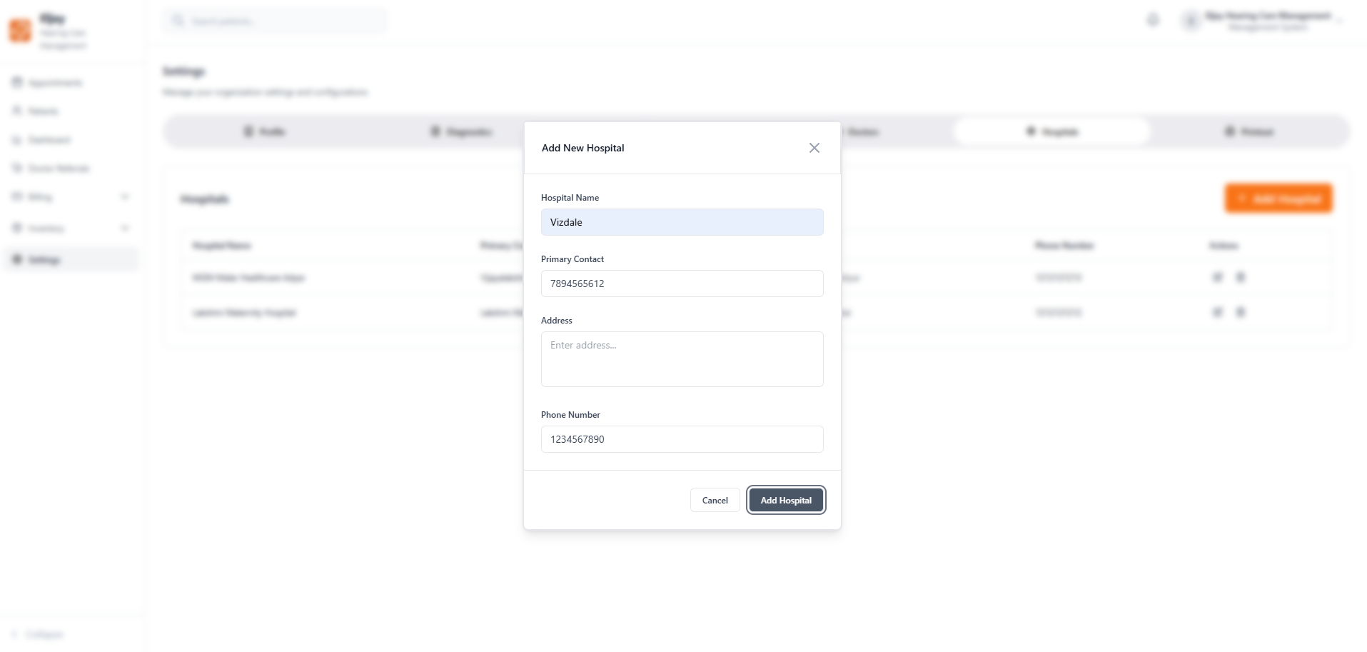

When the sidebar is collapsed, the inventory & billing is not working

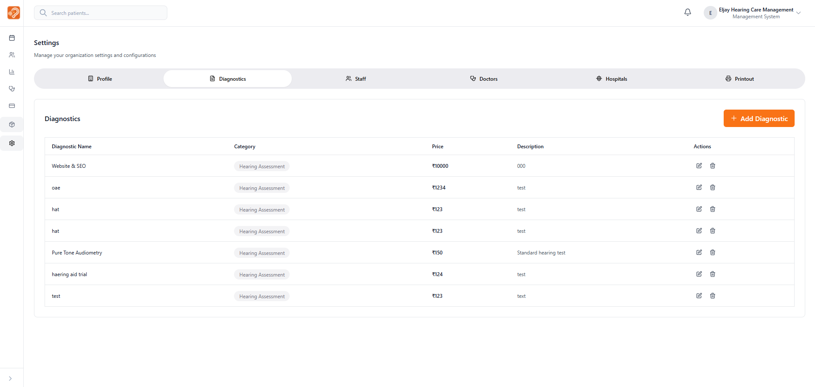

The time must be mentioned in the invoices listing section

There is no provision for deleting an invoice

Invoices should be opened by clicking the invoice name or something else, currently is is difficult to open an invoice.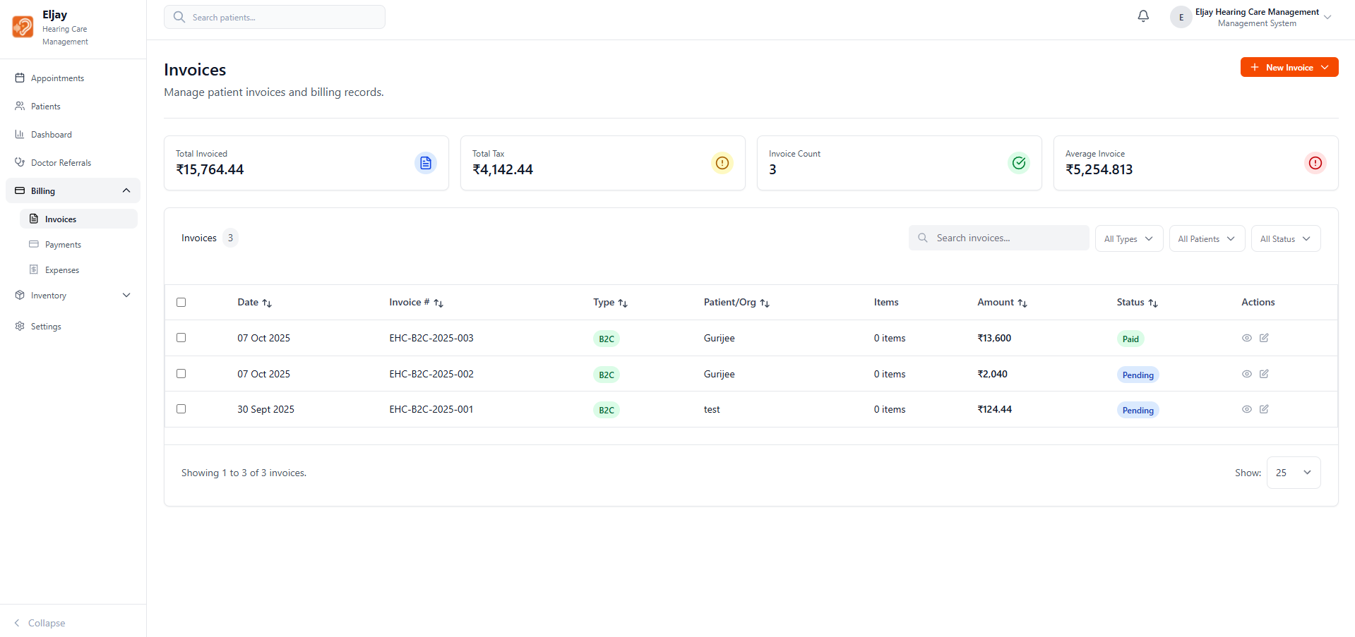

There is no collapse option is not working for selecting the patients, in the billing

Need a select all and clear all button for outstanding receipts.

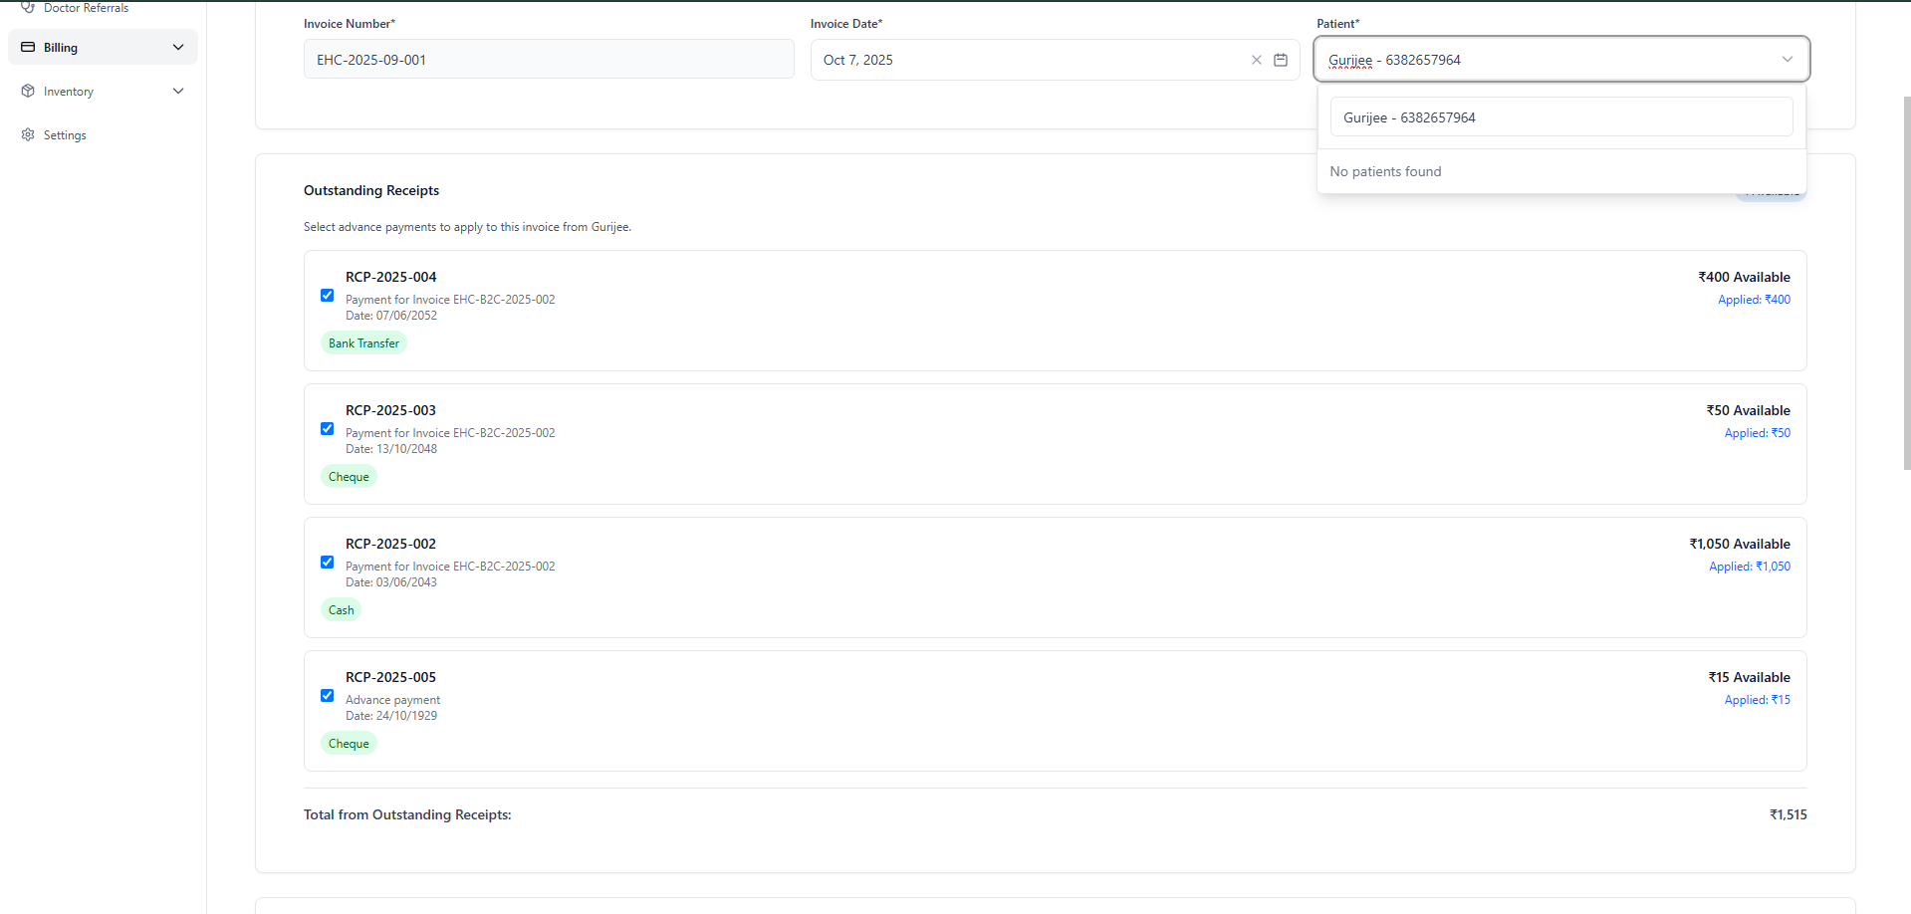

In billing (creating an invoice) while adding items, if more than 2 items are added the users will not be notified or will know that it is added, because the screen is hidden after two items and will be revealed only after a scroll but while a user pressing add item he/she will not know if it is added or now.

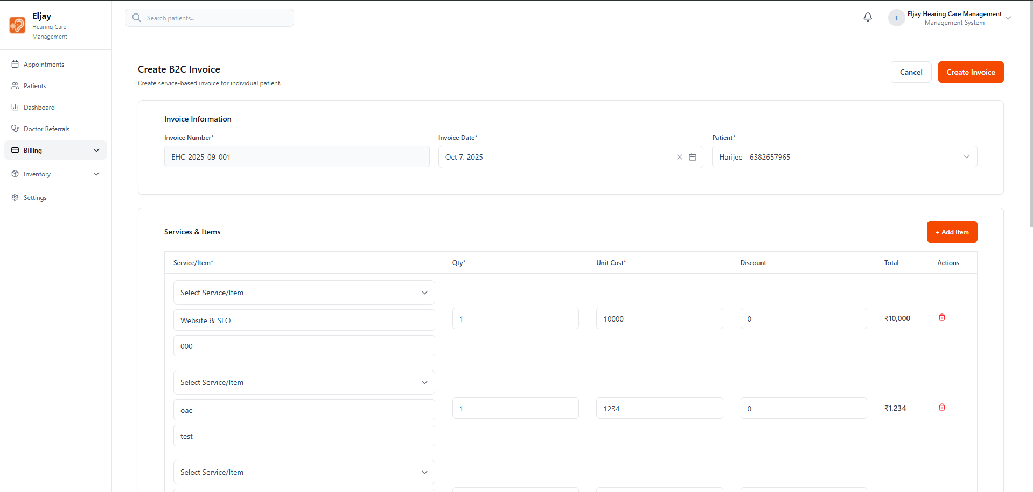

In the inventory, in all the adjustments tabs the action buttons are not working

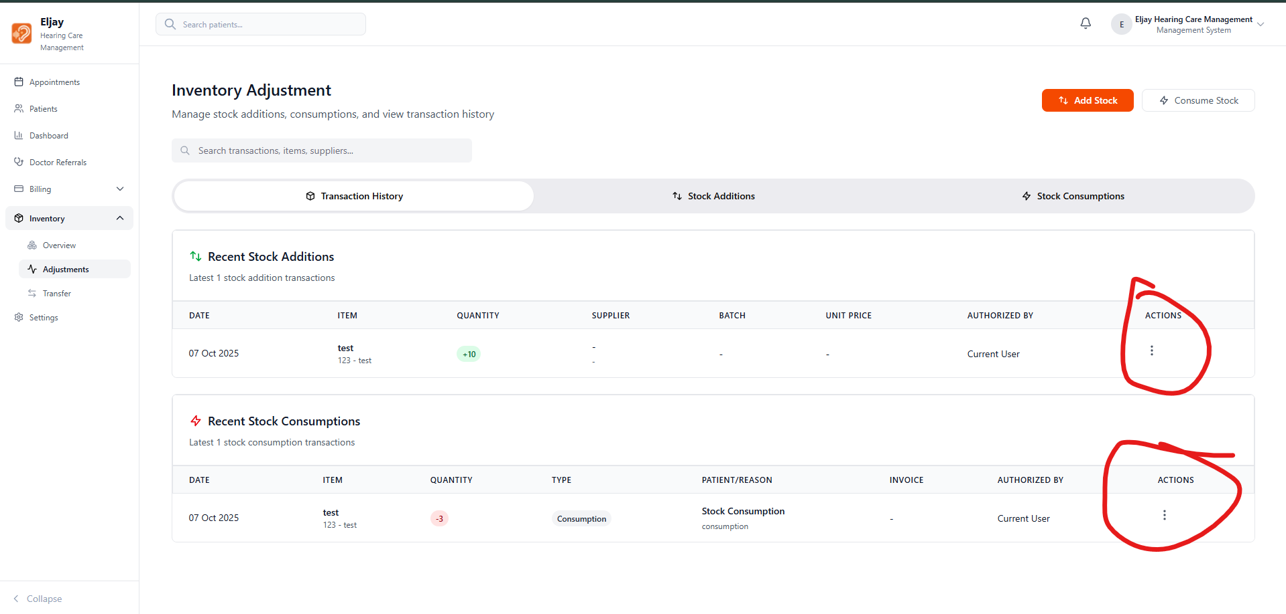

Why is there a view all button here in the bottom right corner?

This page is missing a lot of functionalities, check design file.

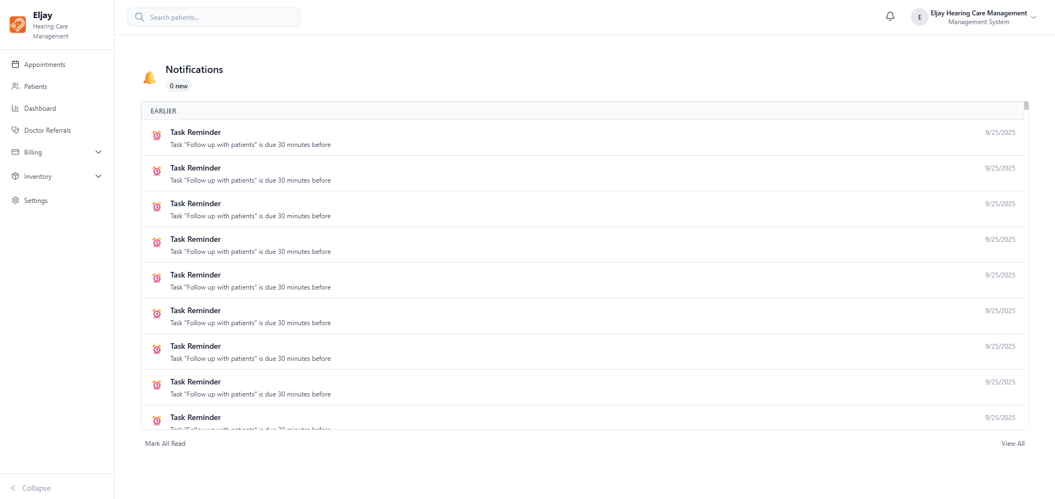

Buttons not working

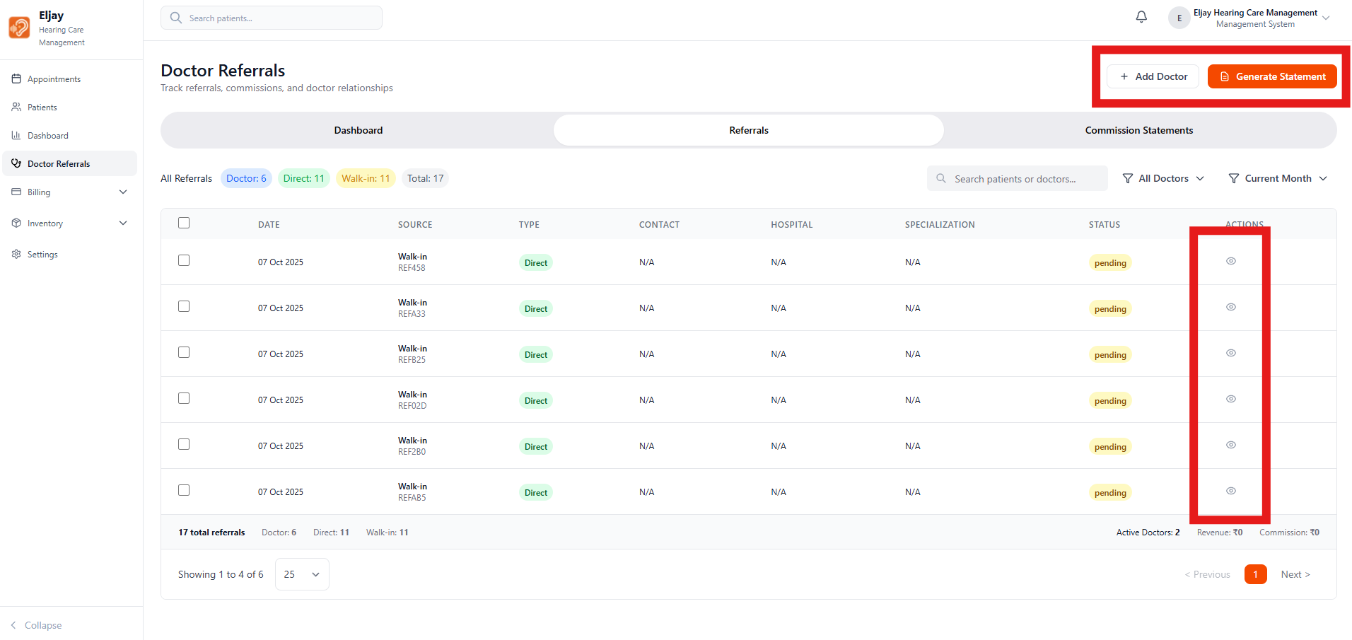

The filter and sort are overlapping here also

